Vermot-Desroches Matthias

Rapport de séance n°15

During this session, I finished placing the ultrasound sensors and fixed temporarily the Arduino card in order to make tests on the obstacle detection program.

I started by making new holes on the opposite side of the frame, as during the previous session I decided to swap the side of the sensors du to a lack of place for the Arduino card. Then, I used tape and a plastic piece to temporarily place the Arduino card on the frame. After that, I linked the sensors, the card and the driver together with cables and started working on the obstacle detection program again. Here are pictures of the frame with the cables:

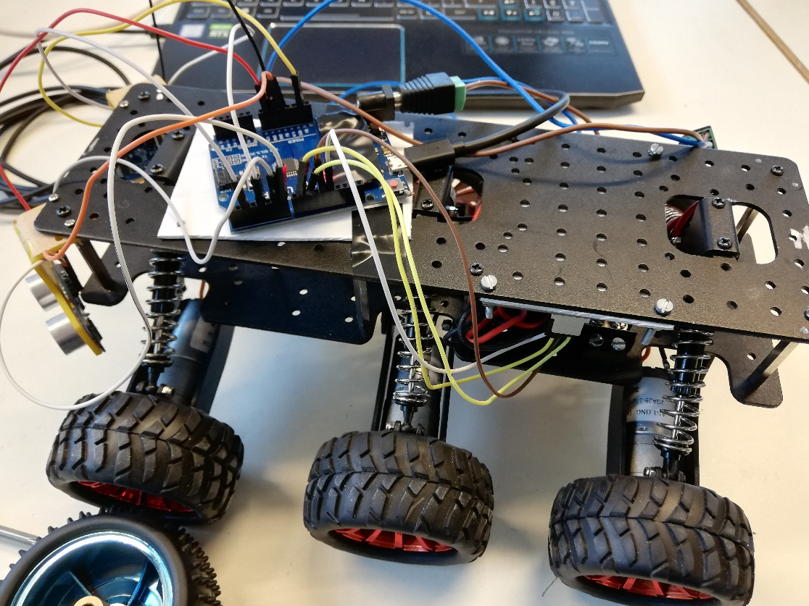

You can see that the cables are outside of the frame for now, but I will put them inside when I decided where I will put the Arduino card.

I downloaded the program in the robot and found out that the link between the card and the driver was not made. What I meant by that is, if I pressed the buttons associated with the motors on the driver, the motors would start to rotate, but they wound not when in action. So I reviewed my code and the cables. After a while, they start working again for reasons I don’t really know. After that, I found out that the motors where rotating in the wrong direction (clock wise instead of anti-clockwise).

So, I modified the program a bit and added cables that were put on the directions port of the driver before starting the tests. The robot could indeed turn when an obstacle was detected, but I needed to modify the detection length.

After that, Mr. Masson told me to have my robot be able to inverse his motors rotation. I made a new function that will inverse it when a large obstacle will be detected. It worked for the first test (avoiding a wall and going through an open door) but didn’t during the next ones. So, I spent a lot of time remaking lots of part of my program, with unsuccessful results. But, I found a possible solution by also inverting the direction of rotation when the motors are in reverse (ex : when the robot is in reverse and detect an obstacle on the right, he will turn on the right instead of the left, making his position further to the obstacle and making it easier to avoid it).

During the next session, I hope the test will be successful so that I can move to the Lidar part of the robot with my teammate.